**Special Theory of Relativity**

Table of Contents

Frame of Reference 2

Inertial Frame of Reference 2

Law of Inertia 3

Reflective Index 4

Cyclotron Betatron 6

Photo-Electric Effect 7

Compton Effect 9

## Frame of Reference

### Inertial Frame of Reference



Proper time is time as measured by someone in the same frame of reference as the event.

For $S$ frame and $S'$ frame, proper time, $t_{0}=\frac{2l_{0}}{c}$

However, from the laboratory, the event in the $S'$ frame is viewed like this:



- time dilation

$$t=\frac{t_{0}}{\sqrt{1-\left(\frac{v^{2}}{c^{2}}\right)}}$$

1st Postulate of the Special Theory of Relativity – all frames are relative

2nd Postulate of the Special Theory of Relativity – speed of light in vacuum is constant

### Law of Inertia

1. There is no universal frame of reference (laws of physics are the same)
2. Speed of light is constant in all inertial frames of reference (in free space)

Inertial frame of reference: One which follows Newton's 1st law accurately.

All measurements are relative and there is no preferable frame of reference. E.g. the length of a plane as measured by someone on the ground will be different from that measured by someone on the plane.

No motion is absolute. It is all relative.

However, the speed of light will not change in any inertial (non-accelerated) frames of reference. People on different frames of reference will still measure the speed of light to be the same.

Mass is also relative. As electrons move at nearly the speed of light, mass varies according to the equation:

$$m^{'}=\frac{m_{0}}{\sqrt{1-\left(\frac{v^{2}}{c^{2}}\right)}}$$

where $v$ is the speed of the electron and

$c$ is the speed of light

Einstein believed that Maxwell's laws are consistent with the theory of relativity, whereas Newton's laws were not. This was later proven correct.

### Reflective Index



- speed of light in vacuum

Speed of conducting electron in this medium can be higher than the speed of light in the medium. This will cause $e^{-}$ to radiate a cone of light bough wave.

$$ω=∫\vec{F}⋅\vec{dr}$$

$=∫qE⋅\vec{dr}$ ($F=qE$)

$$=∫qEdr\cos{θ}$$



Both parts have the same work done. Vertical displacement has no work done as movement is perpendicular to direction of electric field ($\cos{θ}=0$)

$$F=qE$$

$$a=\frac{qE}{m_{e}}$$

$$\frac{dr}{dt}=v$$

$$\frac{d^{2}r}{dt^{2}}=a$$

$$\frac{d^{3}r}{dt^{3}}=jerk$$

$$\frac{d^{4}r}{dt^{4}}=superjerk$$



### Cyclotron Betatron

$eV=E=\frac{1}{2}mv^{2}=\frac{1}{2}mω^{2}r^{2}$ ($ω=v$)

$$r=\sqrt{\frac{2eV}{mω^{2}}}$$

## Photo-Electric Effect

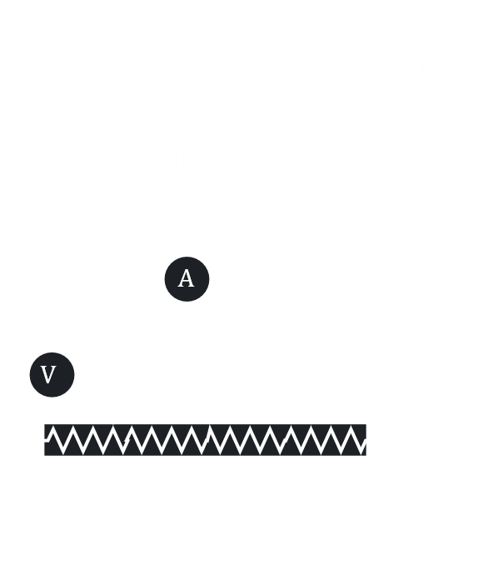

$E=ℏω$ (energy of electron)

$$ℏ=\frac{h}{2π}$$

$$h=6.63×{10}^{-34}Js^{-1}$$

$E=hf$ ($ω=2πf$)

$ω=hf+\frac{1}{2}mv^{2}$ (work done)

If $KE=0$, $ω=hf$- electron is released and reabsorbed since it cannot move away

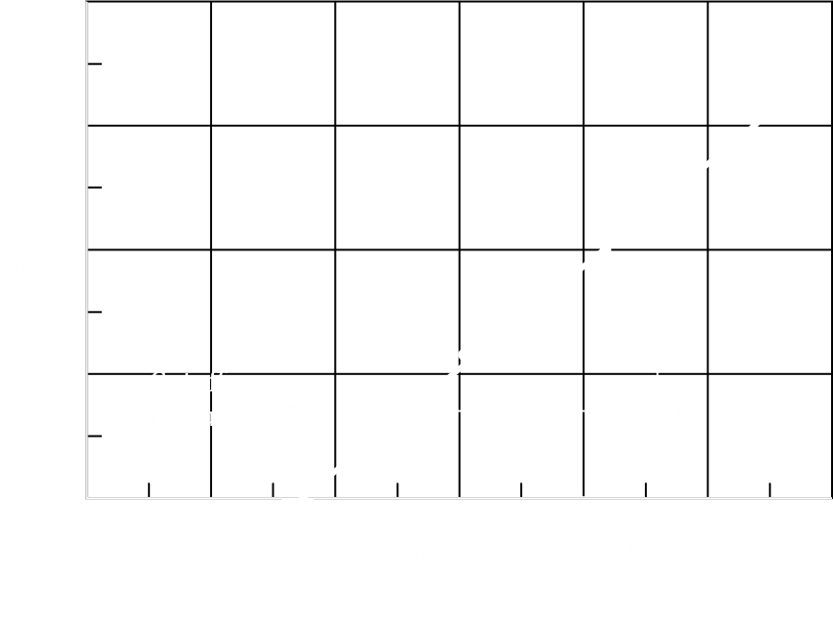

$f_{0}$– threshold frequency

$ω=eVs$ (work function)

Work function is the minimum energy needed to release an electron from a metal. This is for electrons on the surface. Electrons deeper in the metal need more energy.

Stopping Potential: Voltage needed to just stop an electron from reaching the cathode. It depends on frequency of the electromagnetic wave, not its intensity. This indicates the energy of the electron increases with frequency, but not intensity.

As intensity increases, the rate of flow of electrons increases.

## Compton Effect

$$p=mv$$

$$T=\frac{1}{2}mv^{2}$$

$$T=\frac{p^{2}}{2m}$$

Free electron, $V = 0$

$$E=\frac{p^{2}}{2m}=\frac{ℏk}{2m}$$

$$-\frac{ℏ^{2}}{2m}∇^{2}Ψ+VΨ=EΨ$$

$$Ψ=Ae^{i\left(kx-ωt\right)}$$

$$Ψ^{*}=Ae^{-i\left(kx-ωt\right)}$$

$$ΨΨ^{2}=A^{2}$$

X-Ray electrons shift to higher orbits, losing energy

$$1Å=10-10m$$

$$λ=10-8→10-10m$$

Compton wavelength, $λ_{C}=\frac{h}{2m_{e}c}$



$$λ'-λ=∆λ$$

Momentum, $ρ=m_{e}c$

Maximum Compton wavelength when photon has $180°$ rebound



- shift of wave $=\frac{h}{mc}+λ$

Gravity $F_{g}=\frac{Gm_{1}m_{2}}{r^{2}}$

No difference between gravity produced by a mass and that produced by an accelerating body.

When a massive body is shaken, it emits graviton waves.

Light is bent due to huge gravity.